**Graded Assignment On Serverless Architecture**

**Assignment 1: Automated Instance Management Using AWS Lambda and Boto3**

import boto3

ec2 = boto3.client('ec2')

# List of instance IDs to stop and start

auto_stop_instance_ids = ['i-00ad63bbf35948a9c']

auto_start_instance_ids = ['i-0288ee490c4119041']

def lambda_handler(event, context):

    # Stop 'Auto-Stop' instances

    if auto_stop_instance_ids:

        ec2.stop_instances(InstanceIds=auto_stop_instance_ids)

        for instance_id in auto_stop_instance_ids:

            print(f"Stopped instance: {instance_id}")

    # Start 'Auto-Start' instances

    if auto_start_instance_ids:

        ec2.start_instances(InstanceIds=auto_start_instance_ids)

        for instance_id in auto_start_instance_ids:

            print(f"Started instance: {instance_id}")

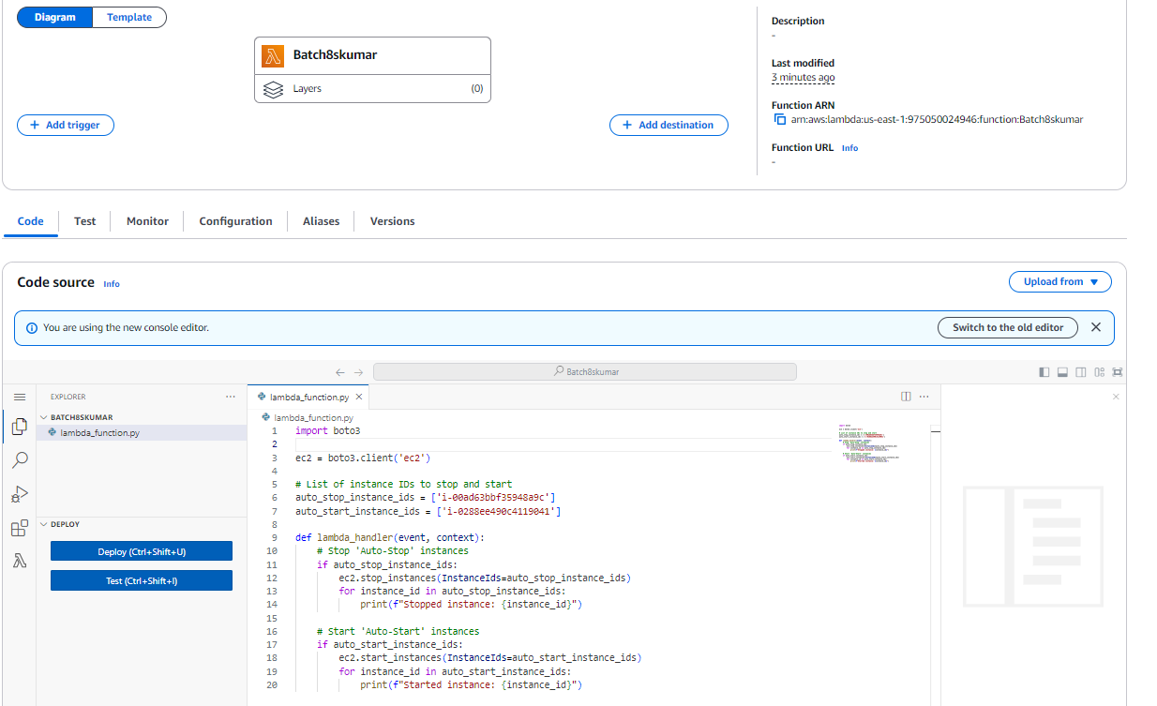



**Assignment 2: Automated S3 Bucket Cleanup Using AWS Lambda and Boto3**

import boto3

from datetime import datetime, timezone, timedelta

# Initialize the S3 client outside the handler

s3 = boto3.client('s3')

def lambda_handler(event, context):

    bucket_name = 'batch8shiv'

    days_old = 30

    cutoff_date = datetime.now(timezone.utc) - timedelta(days=days_old)

    # List objects in the specified bucket

    response = s3.list_objects_v2(Bucket=bucket_name)

    if 'Contents' in response:

        for obj in response['Contents']:

            obj_date = obj['LastModified']

            if obj_date < cutoff_date:

                # Delete objects older than 30 days

                s3.delete_object(Bucket=bucket_name, Key=obj['Key'])

                print(f"Deleted object: {obj['Key']}")

    else:

        print("No objects found in the bucket.")

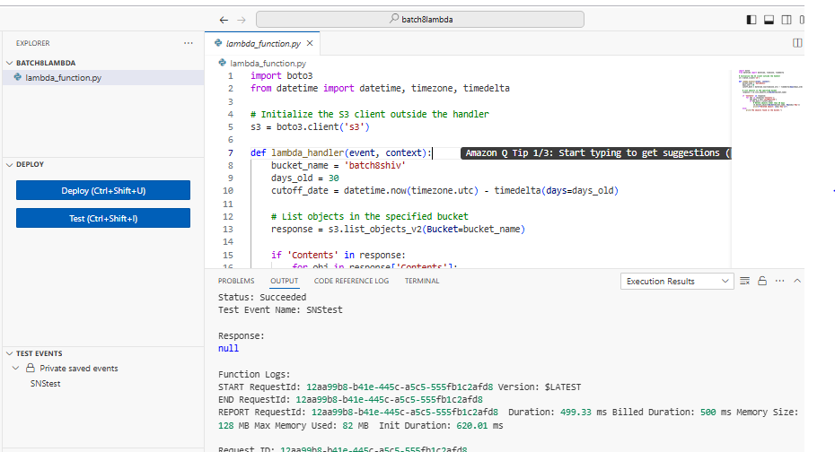

**Assignment 11: EC2 Backup and File Cleanup Using Lambda, Boto3, and S3**

import boto3

import os

import zipfile

from datetime import datetime, timedelta

ec2 = boto3.client('ec2')

s3 = boto3.client('s3')

# Replace with your S3 bucket name

S3_BUCKET = 'batch8shiv'

# Replace with your EC2 instance ID

INSTANCE_ID = 'i-00ad63bbf35948a9c'

# Directory to backup

DIRECTORY_TO_BACKUP = '/home/ubuntu/backup/backupfiles/'

def lambda_handler(event, context):

    # Connect to EC2 instance and create a backup

    ec2_instance = ec2.describe_instances(InstanceIds=[INSTANCE_ID])

    instance = ec2_instance['Reservations'][0]['Instances'][0]

    instance_ip = instance['PublicIpAddress']

    # Create a zip file of the directory

    zip_filename = f'/tmp/backup_{datetime.now().strftime("%Y%m%d%H%M%S")}.zip'

    with zipfile.ZipFile(zip_filename, 'w') as zipf:

        for root, dirs, files in os.walk(DIRECTORY_TO_BACKUP):

            for file in files:

                zipf.write(os.path.join(root, file))

    # Upload the zip file to S3

    s3.upload_file(zip_filename, S3_BUCKET, os.path.basename(zip_filename))

    # Delete backups older than 30 days

    delete_old_backups(S3_BUCKET)

    return {

        'statusCode': 200,

        'body': 'Backup and cleanup completed successfully.'

    }

def delete_old_backups(bucket_name):

    response = s3.list_objects_v2(Bucket=bucket_name)

    if 'Contents' in response:

        for obj in response['Contents']:

            if obj['LastModified'] < datetime.now(tz=obj['LastModified'].tzinfo) - timedelta(days=30):

                s3.delete_object(Bucket=bucket_name, Key=obj['Key'])

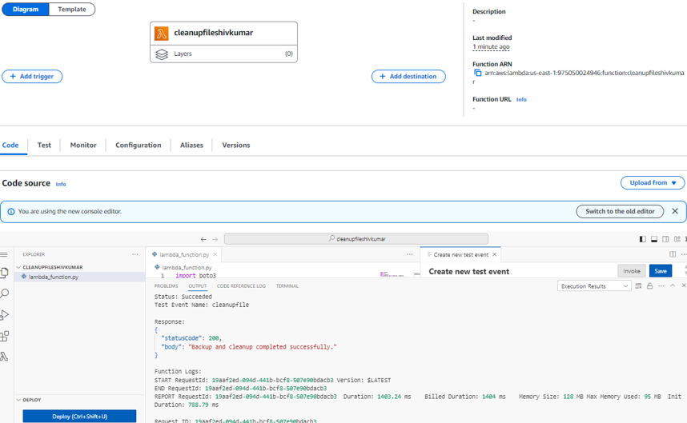

-------------------------------------------

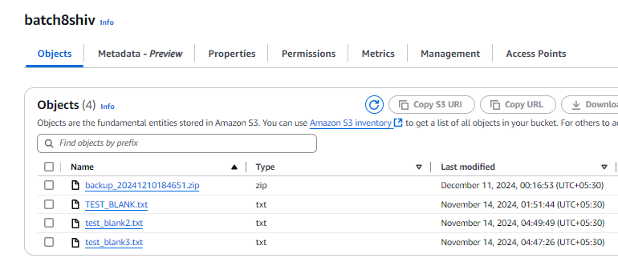

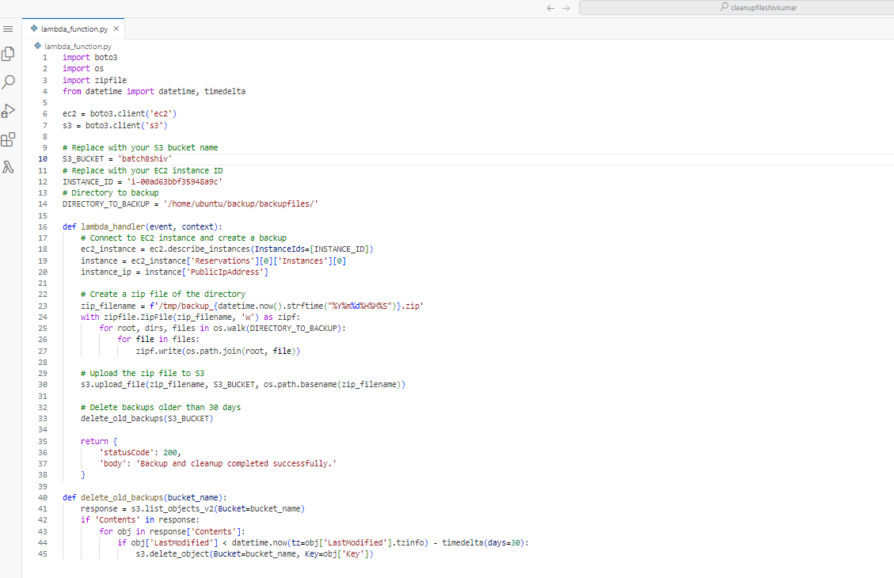

**Assignment 14: Monitor EC2 Instance State Changes Using AWS Lambda, Boto3, and SNS**

import boto3

import os

sns = boto3.client('sns')

# Retrieve the SNS topic ARN from environment variables

SNS_TOPIC_ARN = os.environ['SNS_TOPIC_ARN']

def lambda_handler(event, context):

    # Extract details from the event

    detail = event['detail']

    instance_id = detail['instance-id']

    state = detail['state']

    # Create the message

    message = f'EC2 Instance {instance_id} is now {state}.'

    # Send the SNS notification

    sns.publish(

        TopicArn=SNS_TOPIC_ARN,

        Subject='EC2 Instance State Change',

        Message=message

    )

    return {

        'statusCode': 200,

        'body': 'Notification sent successfully.'

    }





